Week 6 – Inventory Management System
Internship: Developers Arena
Inventory Management System

Programming Language: Java
IDE: Eclipse IDE

Submitted By:
email: akhilathirumani42@gmail.com
ID Number: EMP20260710-8070

1.Project Description
The Inventory Management System is a Java-based console application for managing products, inventory quantities, stock alerts, transactions, and product sorting. It demonstrates Java Collections, OOP, generics, Comparable, custom Comparator implementations, and undo functionality.
2.Technologies Used
- Programming Language: Java
- IDE: Eclipse IDE
- Data Structures: HashSet, TreeSet, LinkedList, Stack, Queue
- Concepts: OOP, Encapsulation, Generics, Comparable, Comparator
- Application Type: Console-based application

3. Project Structure

src
├── model
│ ├── Product.java
│ └── Transaction.java
│
├── comparators
│ ├── NameComparator.java
│ ├── PriceComparator.java
│ └── ValueComparator.java
│
├── collections
│ └── InventoryManagementSystem.java
│
└── inventory
├── InventoryUtils.java

└── Main.java

4. Sorting
The project supports four sorting options:
- SKU: Natural ordering using Comparable<Product>
- Price: PriceComparator
- Inventory Value: ValueComparator
- Name: NameComparator
5.Visual Documentation

- Main Menu

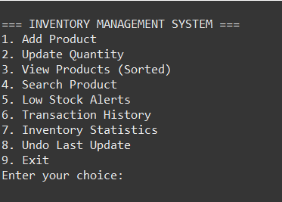

- Add Product
